How to Update Prayer Time

1. Download new schedule, one can be found here <https://thpc.taiwantrade.com/Taiwan_mosque#a2>
2. Edit the image, only use prayer time table like this

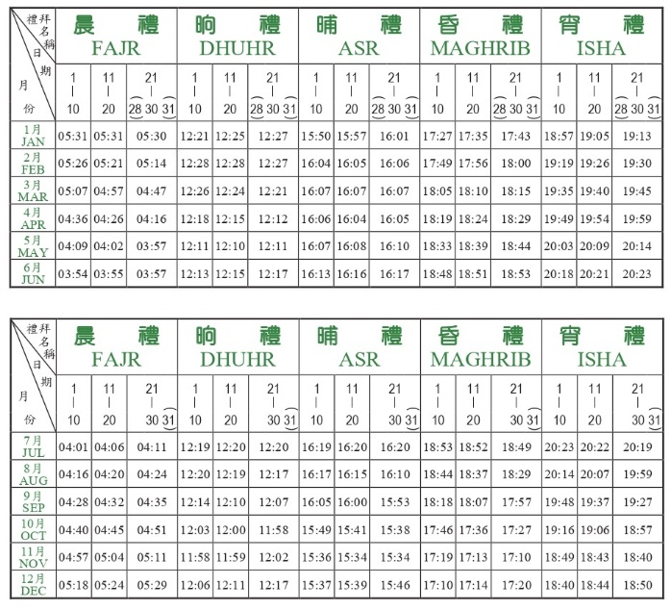

1. Convert to excel using this tool [https://online2pdf.com/convert-jpg-to-excel#](https://online2pdf.com/convert-jpg-to-excel) or any other similar tools
2. Just use the time table date removing the other columns and add header,

From this

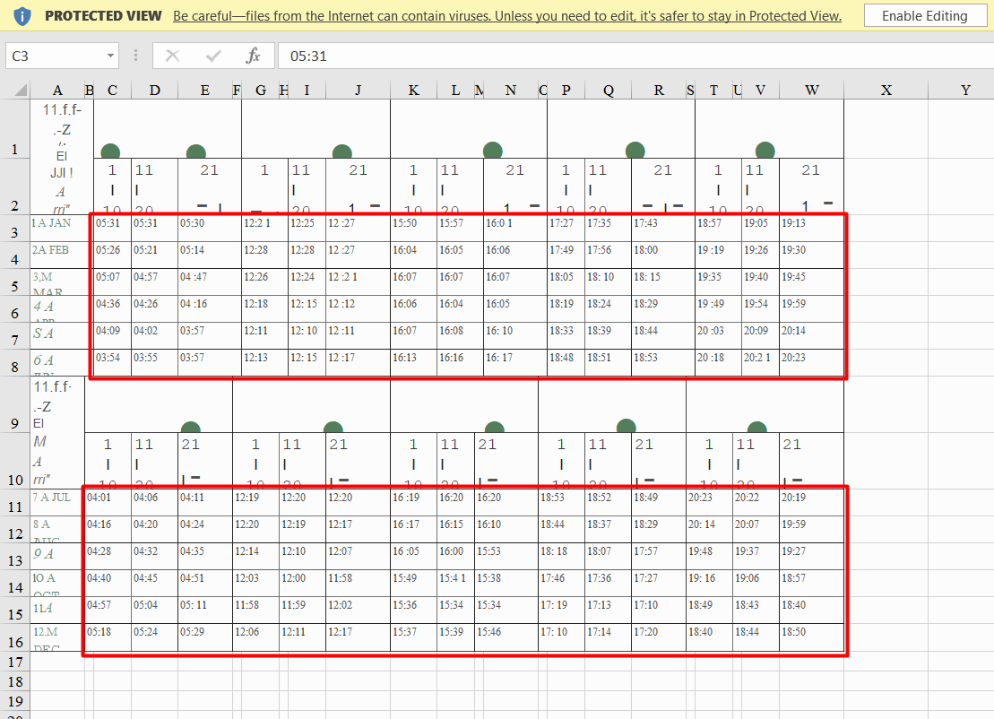

Into this

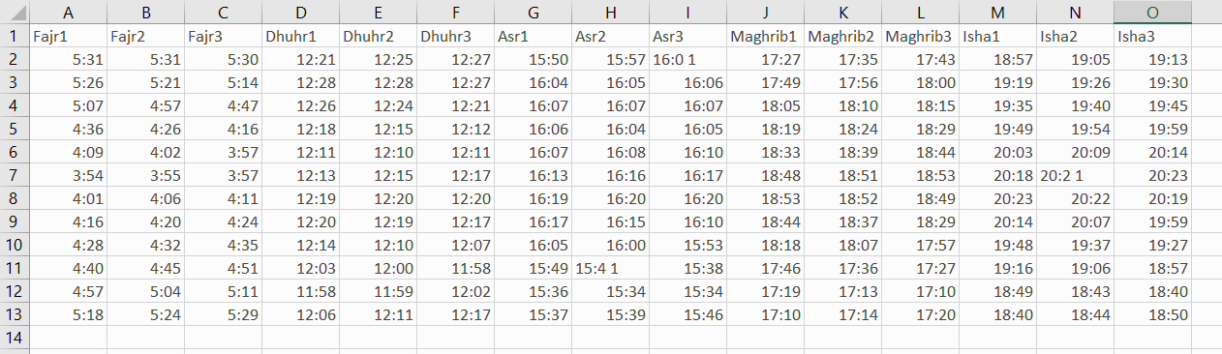

1. Save the cleaned data to timetable.csv
2. Check the file again open it using excel and see the incorrect data to fix it

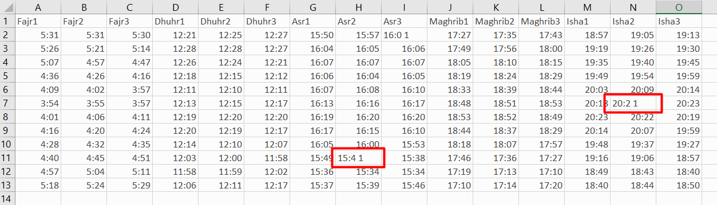

1. After the data is clean, convert to JSON using this tool <https://csvjson.com/csv2json> or any other similar tools
2. Replace timetable.json in the assets folder with the updated file
3. Rebuild and redeploy the app